NORTHWEST NANOOSE RESIDENTS ASSOCIATION
Tuesday, October 18, 2005
7:00 pm – 1391 Madrona Drive – (Kirke’s Home)

IN ATTENDANCE

President Kirke MacMillan
Vice-President Greg Field
Treasurer Frank Herman

Directors at Large Janet Farooq
Mike Gray
Diane Hill
Mike Rich

Regrets: Dave Jamieson

- CALL TO ORDER

The meeting was called to order by Kirke MacMillan at 7:03pm

- PREVIOUS MEETING MINUTES – SEPTEMBER 20, 2005

- Item 6.a. Water and Waste, item two: agreed to change “mandatory yearly inspections of septic systems” to “mandatory periodic inspections of septic systems”
- KM moved to accept minutes; DH seconded.

- PRESIDENT’S REPORT (KM)

- Discussion to clarify current executive committee members (list attached).
- Action: KM to call Jeanne Gregory to confirm her status as a director and Wolf Riedel to confirm his status as a member of the Legislation Committee.

- TREASURER’S REPORT (FH)

- Signing officers have been changed.
- All bills were paid, totaling $703.53, leaving a bank account balance of approximately $900.
- Four $1,000 cashable bonds.
- Credit union has raised interest rate to 2 ¼% from 2%.
- Action: FH will continue to follow up with other investment options.
- Suggest investments not be long-term as interest rates will be going up.
- Action: DH to look for receipt for outstanding invoice per statement received from Parks West.

- WORKING COMMITTEE REPORTS

  - WATER AND WASTE (MR)
- Sprinkling restrictions were lifted completely November 1.
- Supply source was cut over from Englishman River to wells about October 3 (first rains).
- Madrona Heights well still doesn’t have VIHA supply source approval.
- Madrona well (No. 4) good for 20 Igpm; Madrona Heights good for 44 Igpm
- Once approved, Madrona Heights well will form part of area supply.
- Action: MR to follow up to see if RDN is negotiating for Heringa supply well through third party.

- Sewers: nothing new to report. Stymied until OCP and the related funding approved for its Section 5.8 sewer feasibility study.

  - LEGISLATION (KM)
- OCP was submitted to Provincial Government in July. Expect it will be returned in November. November 22nd is the earliest OCP approval date.
- Public meeting was held regarding Land Use and Subdivision Amendment Bylaw No. 500.324. Of primary interest to NNRA members is Part 3 Section 3.9 Setbacks-Sea, which has been amended to read as follows:
“For Electoral Area ‘E’, on parcels adjacent to or containing a coastal watercourse, no building or structures shall be constructed, moved, extended within 8.0 meters horizontal distance inland from the top of a slope 30% or greater; or within 15 meters horizontal distance from the natural boundary, whichever is greater.” (The specific amendment proposed has been highlighted in italics.)
- Bylaw No.500.324 is expected to be approved at the same time as the OCP.
- (Full report attached)

  - SOCIAL COMMITTEE (DH)
- No report

- WATER CONSUMPTION RATE REVIEW (MR)

  - For conservation reasons, RDN wants to reduce water consumption by 18% over two years and hired a consultant to review user rates.
  - RDN asked us to comment on the Consultant’s report. Our comments were provided in late September
  - Partly because of the fact that the Arrowsmith Water Supply (AWS) charges, which we pay on our Property Tax bills, were not accounted for, the consultant’s proposed rates were in our view far too high.
  - RDN is taking all comments into consideration when developing the future rate structure and is keeping George Holme, our Area ‘E’ Director, in the loop.
  - Meanwhile, the RDN Board has approved a modest increase in user metered rates of 2%, effective October 2005.

- OCTOBER NEWSLETTER

- Dave Jamieson’s article on Disposal of Residential Vegetation Material was reviewed and approved to put in the newsletter.
- An article on the NNRA Website prepared by KM will be included.
- Discussion as to whether or not the login and password for the NNRA website should be published in the newsletter. Agreed to do so then change the password before next membership fees are due, at which time the password will be given only to those who pay their dues.
- It was agreed to advertise for an NNRA Secretary.
- Action: Greg to write an article on the mess created by residents leaving flyers behind at newspaper boxes.

- SHELLFISH CLOSURES (KM)

- The closures at Madrona and Wall Beach (as per attached closure maps) for the last several years have been because of streams containing high fecal coliform counts entering the watercourse.
- KM is waiting to hear from DFO scientists in Vancouver on the status of the closures. There appears to be no current Federal or Provincial initiatives underway to resolve the issue.

- OTHER ISSUES

- MEMBERSHIP LIST
- DH to update membership list for the November Directors Meeting.

- EXTRA LANE FOR ENTRY TO CRAIG BAY (JF)
- GF to follow up to find out if there is any plan to add a bicycle lane.

- PARKS ACQUISITION TAX
- Information in a local newspaper indicated that RDN is adding $10 to property taxes for parks acquisition.
- Action: MG to call George Holme for further information.

- ADJOURNMENT

- The meeting was adjourned at 9:00pm.
- Next meeting is the 3rd Tuesday in November (15th) at 7:00 PM at Diane Hill’s home, 1412 Madrona.

Attachments:
- Appendix 1 - Legislation Committee Report
- Appendix 2 - Shellfishing closure area maps

Appendix 1

Legislation Committee

Nanoose Bay Official Community Plan

The Nanoose Bay Official Community Plan Bylaw No. 1400, 2005 was forwarded to the Hon. Ida Chong, Minister of Community Services in July of this year for approval.

As of October 18, 2005, the Regional District of Nanaimo expects that the approved Nanoose Bay OCP will be returned by the Minister in November. Once received, the Nanoose Bay Official Community Plan Bylaw 1400, 2005 will receive 4th and final reading and be adopted. The RDN Board of Directors is scheduled to meet on November 22, 2005.

Land Use and Subdivision Amendment Bylaw Amendment Bylaw No. 500.324

During the August 9, 2005 Electoral Planning Committee Meeting, it was moved that Bylaw No. 500.324 receive 1st and 2nd reading and that it proceed to public hearing.

The Regional District of Nanaimo held a Public Meeting regarding amendments to Bylaw No. 500.423, 2005 on October 13, 2005 at the Quality Resort Bayside in Parksville. Of primary interest to NNRA members was the amendment to Part 3 Section 3.9 Setbacks-Sea that has now been amended to read as follows:

For Electoral Area ‘E’, on parcels adjacent to or containing a coastal watercourse, no building or structures shall be constructed, moved, extended within 8.0 meters horizontal distance inland from the top of a slope 30% or greater; or within 15 meters horizontal distance from the natural boundary, whichever is greater. The specific amendment proposed has been highlighted in italics.

The RDN requested support for this Bylaw Amendment in order to eliminate Development Permit Area IV, Coastal Protection, from the Nanoose Bay OCP. The Public Meeting was attended by only a handful of residents and was over in less than 15 minutes.

In cases where Bylaw 500.324, 2005 results in Nanoose Bay residents running into difficulty when attempting to site new homes or renovate existing homes, there are two separate variance processes that can be followed. The first process involves presenting your case before the RDN “Board of Variance”. In this instance the resident has to prove that the Bylaw causes “hardship”. The second process involves applying for a Development Variance Permit. In this case the variance sought by the resident is reviewed by RDN staff that prepare a recommendation before bringing it before the RDN Board of Directors for a decision. For more detailed information and costs of variance processes, please contact the RDN Planning Department toll free at 1-877-607-4111.

Appendix 2

Area 14 – Sanitary Closures – Closure 14.18 – Craig Creek

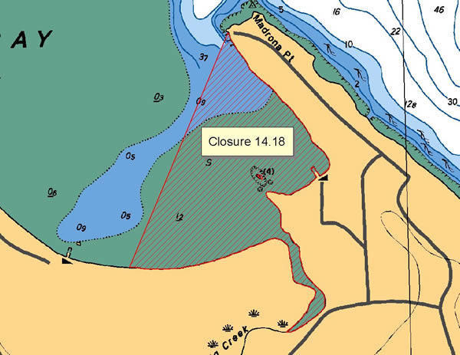
Area 14 – Sanitary Closures – Closure 14.9 – Wall Beach

